

AI prompts for public servants
Save time and work smarter with our cheat sheet for AI prompting

Why prompts matter
Prompts are the instructions or inputs you give an AI tool to generate your desired output. It’s how you steer the conversation and shape the results. This cheat sheet will help you write effective prompts and give you examples to get started.

What makes a good prompt?
Think of a good prompt as instructions for an intern. You wouldn’t hand over a project without explaining the context, task, your expectations and sharing some examples or the materials they’d need to complete the task. Treat AI the same way: if a person would struggle to execute the task, it’s likely AI will too.
Be clear, precise and share as many examples as an intern would need to do the task well. Figure 1 gives you a useful structure for your next conversation with your AI tool of choice.
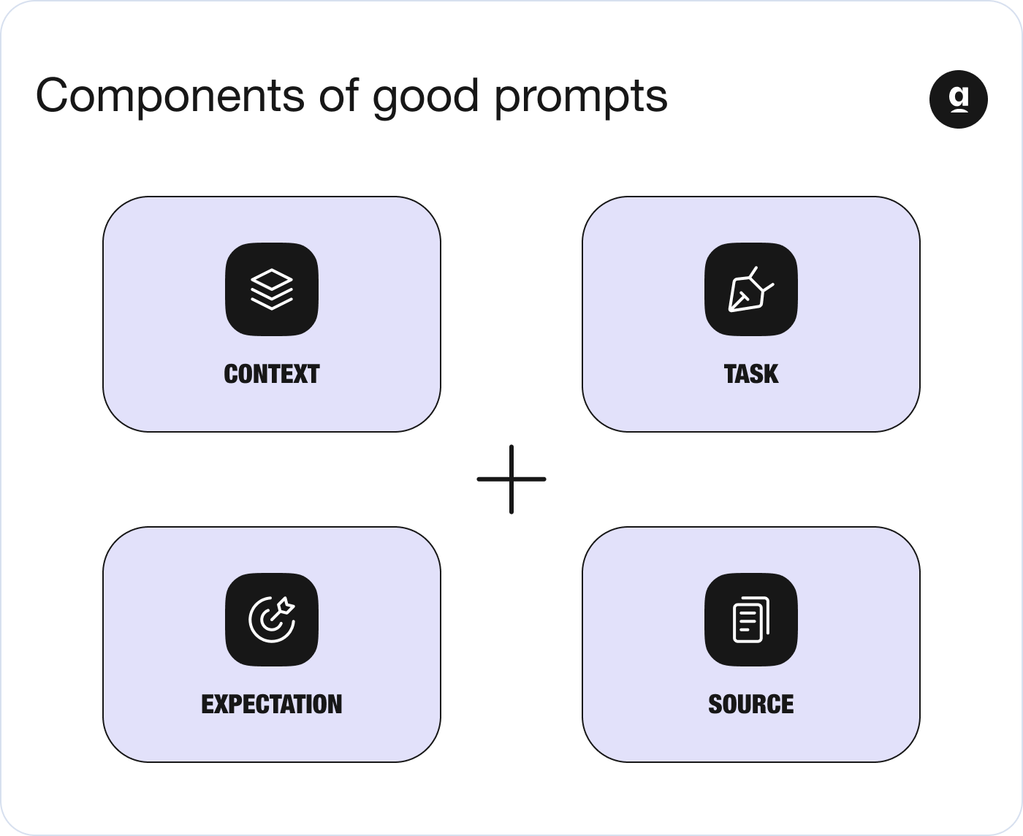Figure 1: This diagram outlines the components of an effective prompt.

Following this prompting approach, AI can speed up your work, helping you:
- Summarise long reports into short, tailored briefs
- Translate policy into plain English for citizens
- Draft communications for different audiences
- Interpret data to support decision making
- Plan stakeholder engagement with clarity
- Prepare ministerial briefings in minutes

Prompt examples
These prompts are examples to help you see what’s possible with AI and get started quickly. Copy and paste the prompts below and experiment with tweaking them to suit your needs.
- Replace bracketed placeholders with your relevant information, following the “context, task, expectation and source” formula where useful.
- Add relevant documents, data or links to provide context.
- Make sure the information and materials you share align with your data and privacy best practices.
- Be clear about the format, tone and audience.
- Always review the AI’s outputs before sharing to ensure alignment with your organisation’s standards.¹
- Policy brief: “I am a [job title] working in the [department] of [ministry]. Please summarise the key points in the document attached, titled [document name]. Provide the summary in bullet points, using plain English. The summary should be tailored to [audience], who are [characteristics].
- Grievance management: “Analyse the attached letter, sent to the department by a citizen. Translate and prepare a summary that includes: Issue, Location, and the relevant Department.”
- Stakeholder engagement plan: “Draft an outline for an engagement plan for [service/scheme] of [department]. Include all key stakeholders, channels and a timeline. The goal of the engagement is to [purpose — e.g. Get citizen feedback/increase awareness/improve outcomes].”
- Risk analysis: "List the top five risks associated with [topic or area of concern] in [city/region]. Provide mitigation strategies for each, considering [factors]."
- Communications draft: "Write a professional email draft to respond to the attached RTI (Right to Information) query from the citizen about [service]. Ask me questions needed to prepare the response. Keep the tone empathetic and professional."
- Internal strategy summary: "Summarise this strategy document [paste text] into a 1-page briefing note. Use headings: Call for action, Context, Objectives, Risks. Assume the reader is a senior official."
- Scenario planning: "Create three future scenarios (best case, worst case, likely case) for the [initiative]. Include implications for [stakeholders]."
- Data interpretation: "Interpret the following data [paste data table]. What trends stand out over the past three years? Suggest two hypotheses and one policy response."
- Accessibility review: "Evaluate this service description for accessibility: [paste text]. Suggest three improvements to make the content clearer for low-literacy or ESL readers."
- Draft a ministerial briefing: "Create a 300-word briefing for the Minister for [policy area] on recent public concerns about [topic]. Use a factual tone and include three recommended actions."
- Budget deviation analysis: "Highlight areas in our budget where actual spending differed from planned amounts. Present a table: Account, Planned, Actual, Variance %, Cause."
- Comparative visualisation request: "Generate three charts showing [service uptake] across urban and rural regions since [date]. Use a consistent format with labels and source notes."
- Programme evaluation gaps: "List data gaps in evaluating [programme name]. Include why they matter and a recommended proxy indicator for each in a table."
- Logic model design: "Draft a logic model for [policy area] linking inputs, activities, outputs and short-term outcomes. Present as a 4-column table for inclusion in a strategic document."
- Compliance checklist review: "Review this compliance checklist [paste text]. Label each item compliant/partial/non-compliant and suggest next steps with deadlines and owners.”
- Creating procurement documents: “The [department] is looking to procure [product/service] to solve [problem]. Do a market analysis for the problem and create a suggested scope of work.”
- RFP bid comparison: "Create a comparison table of bids for the [programme name] RFP. Use the GFR (General Finance Rule) format for preparing the comparison.”
- Forecast visualisation: "Convert this multi-year spending forecast (attached) into a visual (stacked area chart). Include periods, categories and totals for a leadership briefing.”
- Role-play scenario: "Act as a concerned citizen. Ask three questions about [topic]."^{1,2,3}

Tips for getting the most out of AI
- Use follow-up prompts to iterate ("Make it more concise," "Add examples," "Change tone").
- Paste real documents, messages or datasets into the prompt.
- Be transparent when using AI to draft external comms. Always keep a human in the loop for the final review.
- Experiment with role-play: "Act as a city councillor..." to simulate interactions.
- Add clarifiers like region, deadline, constraints or user group for better results.
- Adding a polite tone (e.g., “please summarise” or “could you draft...”) can sometimes lead to more helpful and conversational responses.
Want to go deeper? Check out Apolitical’s resources.
- Course: Effective Prompt Engineering for Public Servants
- Community: Prompting like a pro? Share your tips
- Article: How to write prompts to get favourable answers from Copilot
- Article: 5 AI tools helping civil servants do more with less
- Webinar: Designing effective AI prompts
- Webinar: How to use AI tools in your work in government

Sources
- OpenAI (2024) ‘Government prompt pack for analysts’. Available at: https://academy.openai.com/public/blogs/government-prompt-pack-for-analysts (Accessed: 15 July 2025)
- Haisler, D. (2023) Making ChatGPT work for you: A generative AI prompt guide for public servants. Center for Digital Government. Available at: https://media.erepublic.com/document/CDG23_GUIDE_ChatGPT_V.pdf (Accessed: 15 July 2025)
- Haisler, D. (2023) Prompt guide for public servants: 50 example ChatGPT prompts and best practices. Center for Digital Government. Available at: https://static1.squarespace.com/static/54a6edaae4b0f3612b117e27/t/643aee14bf03161a04541384/1681583638118/Public+Sector+Prompt+Guide+-+V1.pdf (Accessed: 15 July 2025).

