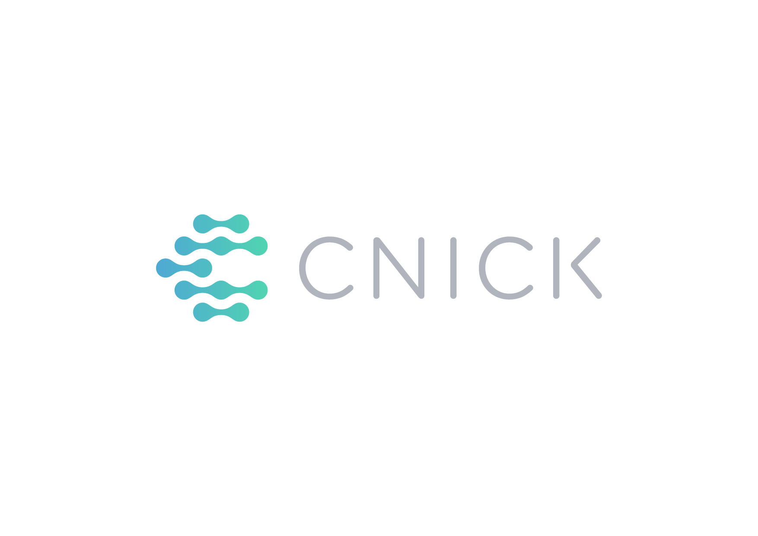
Who we are | CNICK - Future on your hand | CNICK is the first Georgian high-tech Startup to enter US market. We believe in simplicity and beauty of the technologies. We develop Smart NFC Ring that replaces access card, manages smartphone and shares information. CNICK wants to eliminate all barriers helping people to concentrate on things that truly matter. The ring was born in Tbilisi, so we have a huge passion to create an outstanding experience for city visitors. We want to connect your and city’s heartbeat using innovative technology.

Whom we help | Target audience | Out of 3.5 MLN international visitors in Georgia 75% are leisure travelers. Our target audience is digital native millennials. They face diverse challenges. For example, millennials, are engaged, adventurous and open to new ideas. Also, every third traveler will up travel spend next year, which gives the city huge opportunity to boost the nighttime economy.

Key insights | Arriving in a new city is full of challenges: you want to experience the best of it, BUT...
- Variety of different tickets, passes, discount offers, hundreds of city guides will make even experienced traveler confused. Tired of waiting in line to see your favorite DJ?
- Necessity to spend hours and hours reading blogs, forums, BOOKING.com, TripAdvisor ratings etc. will make you waste your precious time in a new city, especially for nightlife. Reliable source would be a key to your action.
- Bored to go with the flow to typical tourist sites? Are you are striving for adventures and unique experiences? Daytime you see the city, nighttime you feel it!

A New city is a jungle, feeling insecure is okay, but we’ve got you covered!


Product Idea | Introducing CNICK-Ki ( „Ki“ in Georgian - yes) your key to night city - ring with special design - Georgian flag colors, that will open every door of Tbilisi Nightlife with a single gesture - or as J. R. Tolkien would say “ One ring to show you all”.

- RING - CNICK-Ki is your VIP city night pass. Public transport, museums, pool parties, casinos, festivals, discount for restaurants - all in one ring, with no extra charge. Skip a line and be the first to see your favorite DJ! Want more? Enjoy your loyalty points accumulated on the ring for special amenities or your next trip to Tbilisi.

- APPLICATION - Can't find the place to try best Khinkali? We have a local advisor to guide you. Collaborationg with city hall, we developed unified platform for your comfort. With CityApp, you can access most reliable information about daytime Tbilisi: public transport, top destinations, most delicious restaurant, WiFi hotspots, and best gift ideas #MadeInGeorgia. And when it gets darker CityApp discloses night mode of app only for CNICK-Ki users – special offers, best events, unique night tours and quests only natives would know.

- GAME – Try yourself in a chase to become a City Hero. Unique concept of super fun night outdoor adventure - Tbilisi Urban Quest. Follow the instructions of the NightApp, explore the city, compete with others, check-in as many places as you can with CNICK-Ki ring and get rewarded with hidden surprises and discounts.

Don't forget that you bring back home CNICK - Ki ring, the best reminder and expression of your unforgettable night adventures.

Security is our priority.
We guarantee unprecedented extra security for CNICK users – your ring will include your medical information, Insurance ID and friend's contact, that can only be accessed in case of emergency.
One time initial price - 89$ Unlimited pass for 3 days
+ 29$ for each next 3-day prolongation.

Business Model | Company CNICK will have 3 strings of revenue:
- From direct sales of the ring;
- From ads in CityApp;
- Sell statistics - Tourists interests and beravior patterns – to government and businesses.

Campaign Objectives:
1. Create intensive and unforgettable night experience in Tbilisi, that no other country has ever done before while keeping you extra-safe and secured;
2. Make CNICK-KI ring an international symbol of Tbilisi nightlife and position the city as innovative.
3. Facilitate local businesses to see nightlife potential clearly for further development;
4. Engage tourists to Spend more by providing a wider range of activities.
KPIs
- 50 000 App downloads
- 5 000 rings sold
- 3 000 games played
- Tbilisi Nightlife income increase by 10%

Key Messages | Accept CNICK-Ki to experience the best Nightlife and become Tbilisi Hero | Feel the city with no limits.

Tone of voice | Encouraging, Energic, fun, trustful and friendly.

Deliverables | Budget | Timeline:
- App Platform - with information about night destinations, game, loyalty system $ 15 000, 3 months;
- Video - describing the whole idea and the fun it can deliver to those involved. $ 8 000, 1 month;
- Stand design and assembly for Airport POS – $5 000, 1 month;
- Brandbook and communication template – $2 000 2 weeks.
Overall - $ 30 000, 3 Month.

Communication Channel





Other Digital Channels:







